**University Institute of Information Technology, PMAS-Arid Agriculture University Rawalpindi Pakistan**

**FAMILY GPS TRACKER USER MANUAL**

# By

**Jawad Ahmed 18-ARID-3020**

**Hassaan Ahmed 18-ARID-3016**

# Supervisor

**Ms. Farkhanda Qamar**

# Bachelor of Science in Software Engineering (2018-2022)

First , you have to link the devices and for that you need to generate the code

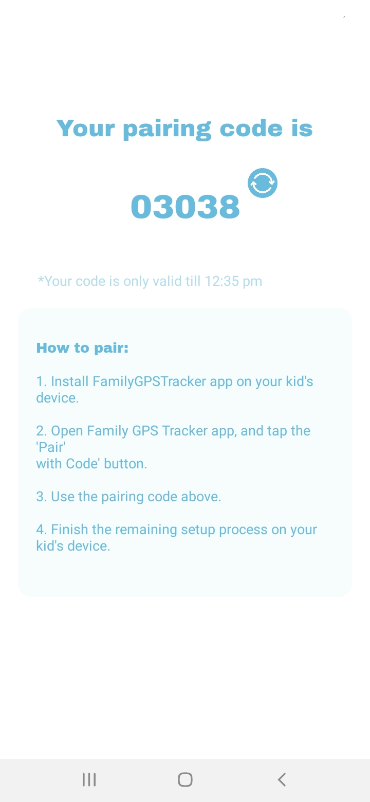

Enter the pairing code on family member’s phone to link the device

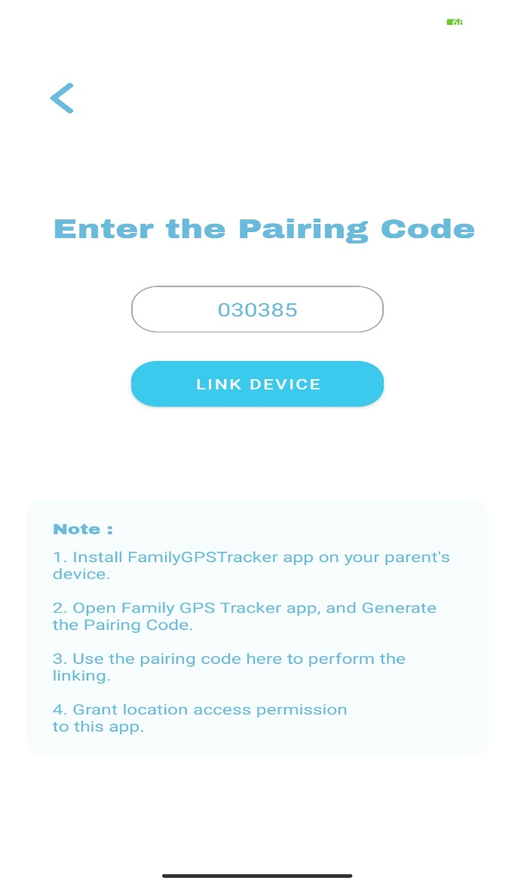

Connect the device to start the supervision

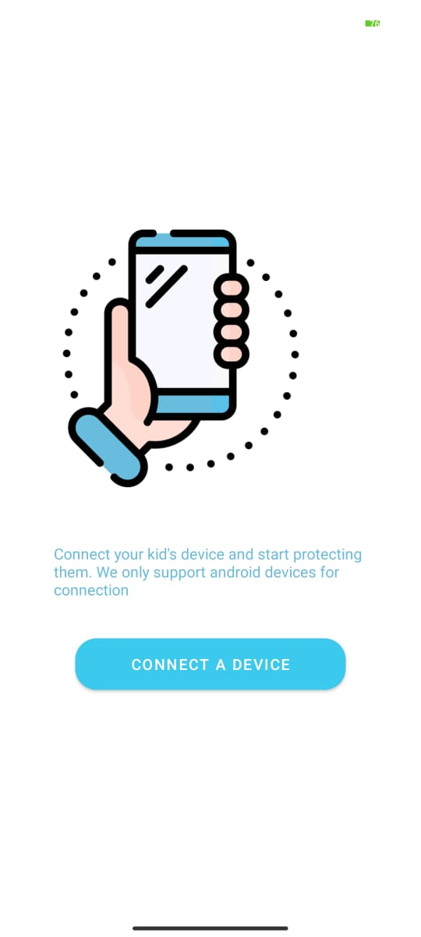

After you gain access to main sceen , you can select the family member from the list and start tracking them

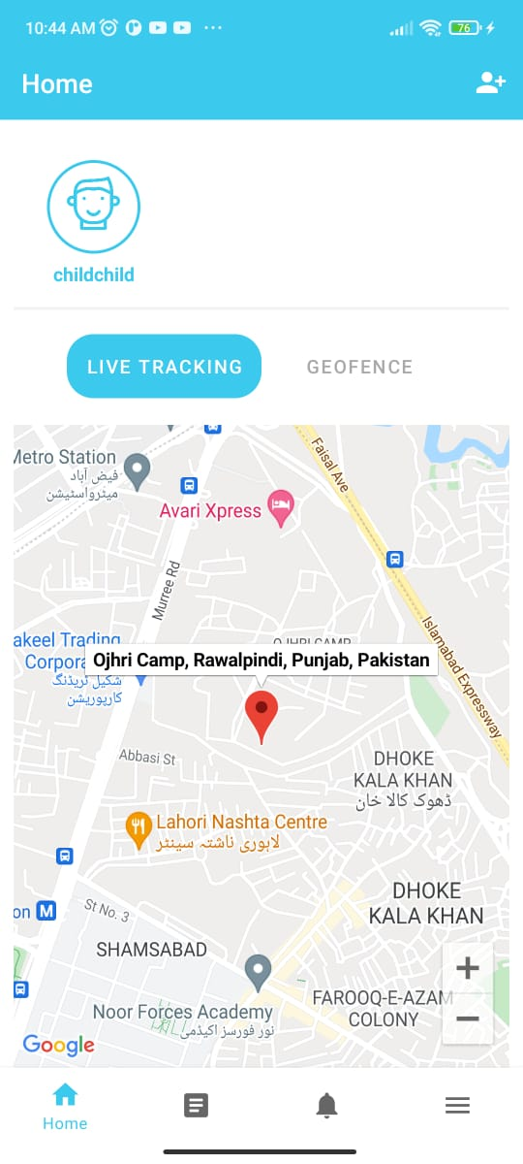

You can have whereabouts information for the whole day from location history section

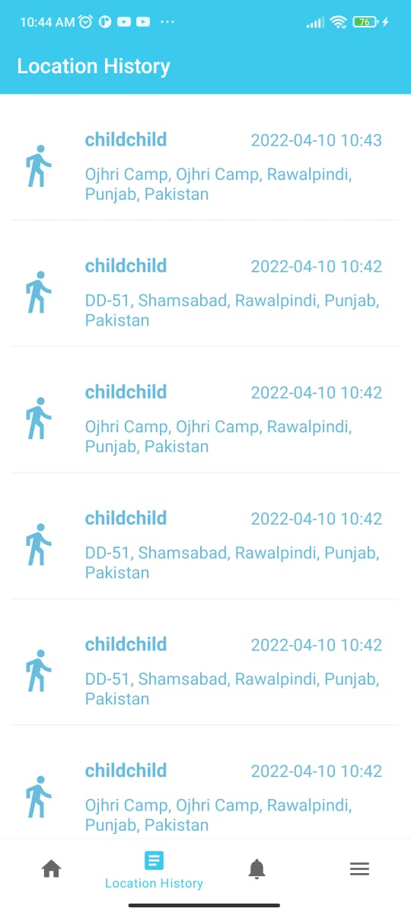

You can view all the notifications received by you from the notification section

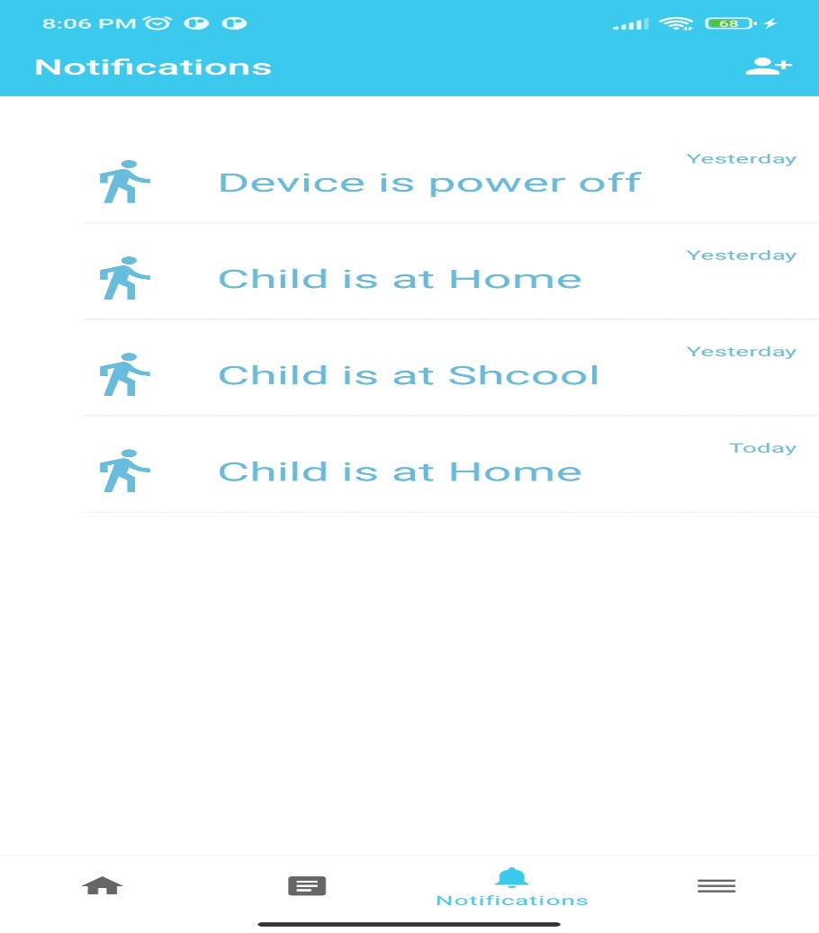

You can view the user details from the profile menu

